**Java type casting – Inheritance**

Converting one type of value to another is called as **Type Casting**.

**Different Forms of Type Casting :**

There are two types of type casting.

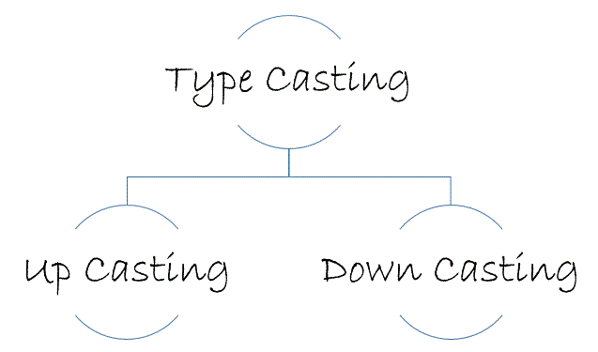

**Live Example of Type Casting in Inheritance :**

***package*** *com.c4learn.inheritance;*

***class*** *Vehicle {*

***String*** *nameOfVehicle;*

*}*

***class*** *TwoWheeler* ***extends*** *Vehicle {*

***String*** *vehicleModel;*

*}*

***public******class*** *TypeCastExample {*

***public******static*** *void main(****String****[] args) {*

*Vehicle v1 =* ***new*** *Vehicle();*

*Vehicle v2 =* ***new*** *TwoWheeler();*

*TwoWheeler v3 = (TwoWheeler)* ***new*** *Vehicle();*

*TwoWheeler v4 =* ***new*** *TwoWheeler();*

*}*

*}*

**A. Up Casting :**

You can cast an instance of a child class to its parent class. Casting an object of child class to a parent class is called **upcasting**.

Consider the following example, Assuming that TwoWheeler is a subclass of Vehicle.

*Vehicle v2 = new TwoWheeler();*

**B. Down Casting :**

Casting an object of a parent class to its child class is called **downcasting**.

Consider the following example, Assuming that TwoWheeler is a subclass of Vehicle. Following is an example of the down casting –

*TwoWheeler v3 = (TwoWheeler) new Vehicle();*